Atlantic Salmon Habitat Conservation Program
Stewardship Association of Municipalities (SAM)

Created by: Outreach Coordinator Karleena Squires

This programming has been developed thanks to funding from the Atlantic Salmon Conservation Foundation (ASCF). This programming is appropriate for grades K-12 - activities can be chosen/adapted based on the age group. This program can be delivered in person or virtually.

OBJECTIVE

Participants will learn about Atlantic Salmon, including their life cycle and their values in Newfoundland and Labrador. This program provides some building blocks for a lifetime of active and thoughtful engagement with Atlantic Salmon Habitat and other natural spaces. Participants will:
- Learn about the anadromous Life Cycle of the Atlantic Salmon, and how it depends on its habitat at different stages in its life;
- Experience time in or learning about nature (specifically, Atlantic Salmon Habitat) that is beneficial to their mental and physical well-being, which can encourage continued exploring of nature;
- Develop deep and critical thinking strategies on conservation and habitat protection;
- Learn about the connections between Atlantic Salmon and Indigenous cultures.

OUTLINE

- Introduction and Atlantic Salmon Presentation
- Activity (complete at least 3, with 1 being a Life Cycle activity, and another being a Salmon Survival activity)
All Ages / Younger Groups / Older Groups
  - Optional Resource
  - Interpretive Walk
  - Life Cycle Relay Race
  - Life Cycle Mismatch*
  - Craft: Toilet Paper Roll Painted Fish
  - Deep Thinking: Conservation Brainstorming
  - Salmon Survival Tag Game**
  - Salmon Survival Scenarios
*This activity is intended for virtual groups
**This activity is intended for in-person groups
- Closing

Prior to the meeting, confirm time, location(s), number of attendees, and presence of supplies with the group/class leader.

OPTIONAL RESOURCES

- You may want to check out/distribute these optional resources prior to the event, or use them during the event.
  - The Interactive Salmon Life Cycle game created in partnership with Gespe’gewaq Mi’gmaq Resource Council, First Mobile Education and Ingenium Canada’s Museums of Science and Innovations Team resource:
    - https://oceancareergames.com/games/SalmonCycle/SalmonCycle.html
  - The Life Cycle of the Atlantic Salmon animation video
    - https://www.youtube.com/watch?v=2fGLzEvWuYA

INTRODUCTION

- Introduce yourself - who are you, your position, what do you do, etc.
- Land Acknowledgement: In the spirit of respect and friendship, we acknowledge that we practice conservation on traditional lands that have been, and continue to be, inhabited by the Indigenous Peoples of Newfoundland and Labrador. We are thankful to all the generations of people who have cared for these lands, and recognize and deeply appreciate their historic connections to these places. SAM recognizes our shared responsibility in conserving these special places and seeks to assist communities in achieving this goal.
- Introduce SAM, here are a few important notes:
  - SAM helps protect important habitats in our province.
  - What is a habitat?
    - Everything an animal or plant needs to survive: all habitats need to have food, shelter and water.
  - What are some examples of habitats in your community?
  - SAM helps to protect important habitats within many communities across the province. (Include an example from their community if they are a SAM Community).
  - What are some threats that we would need to protect these habitats from?
    - Climate change, development, pollution, flooding, etc.
  - Present the Atlantic Salmon Presentation - you will notice there are speakers’ notes on the slide, you can use these to compliment the slides and provide more information. If you are doing a walk, these are great speaking points and we recommend bringing them along.

ACTIVITY: INTERPRETIVE WALK

- In person - invite SAM to help run your walk or run it yourself!
- If the weather permits, start the event off with an interpretive walk - programming activities can be completed along the walk.
- Recommended walk locations can be a local salmon river, salmon/fish ladder, ideal salmon habitats.
- Provide information about salmon and their habitats while in the field that you would provide in the presentation when indoors/virtual (can be found in the Speaker’s Notes).

ACTIVITY: LIFE CYCLE RACE

- In person
- Supplies needed: Salmon Life Cycle Cards (Appendix A) - you will need several sets - approximately one set of seven cards for every 3-5 people. Typically aim to have at least 4 sets. Each set should be delineated with a colour/number/etc. on the back so each team knows which ones belong to them.
- If possible, get access to the room/area 5 minutes beforehand and hide all of the cards in the room. If there is no early access, ask one of the leaders/teachers to assist with hiding them while you are doing your introduction. If not able to, simply mix up all the cards and scatter them in the general vicinity.
- Divide into teams. Explain to them that hidden/scattered around the room are the different stages of the life cycle of a salmon. Team members must search for their missing pieces until all pieces are located. Once they are all located, the teams must put the life cycle of the Atlantic Salmon in the correct order. First one to finish wins!

ACTIVITY: LIFE CYCLE MISMATCH

- Virtual - if doing small groups, ideally you may want to use breakout rooms.
- Switch to our Salmon Life Cycle Mismatch Jamboard (https://jamboard.google.com/d/1Rsa1r1hlY88ihlApNDC-X76GmGXbM84E0zkkj-V7TTM/edit?usp=sharing) - if the previous group did not reset them, you may want to reset before starting. Each person or group (depending on the size) is assigned one of the Jamboard Slides - these are located at the top, and are numbered - duplicate slides to add more if needed.
- Have them use the Jamboards to reorder the life cycle from start to finish.
- If possible, please reset the Jamboards.

ACTIVITY: TOILET PAPER ROLL FISH

- In person or virtual
- Supplies needed: toilet paper roll per person, scissors, paint (variety of colours), paint brushes, optional: googly eyes (plus glue if they don’t have sticky backs), markers, other supplies they may want to use but are optional: such as glitter, stickers, etc. to decorate
  - Many groups may have most if not all of these supplies on hand, ask the group a week prior to the meeting. If not they may need to be supplied or ask the group to pick them up.
  - If completing this virtually, ensure group leaders have enough time to distribute supplies or to ensure their youth have them available at home.
- Instructions: See Appendix B. Instructions can be provided directly to the participants, or given to the group’s leaders to assist. Groups may want to paint the tube prior to the presentation at the beginning so it has time to dry, then complete later on in the evening. Make sure participants do not use too much paint. Optional: show a picture of an Atlantic Salmon if they would like to paint them authentically.
- While the craft is being completed, discuss with the participants the following:
  - Why do you think it is important to protect animals like the Atlantic Salmon?
  - What are some ways that you can help protect them?

ACTIVITY: CONSERVATION BRAINSTORMING

- In person or virtual
- Supplies needed: In Person - chart paper or bristol boards (large paper), markers / Virtual - blank Jamboard/Whiteboard - whatever app they have available.
- Divide into smaller groups (virtually you can use breakout rooms), or complete all as one group. Explain the following situation:
  - David just bought a new house in Deer Lake, NL. He is excited because his property is a natural piece of land along the beautiful Humber River. David loves the environment, and he has seen lots of fish in the river - meaning he can fish right from his backyard! He hopes to build a dock with a boat launch, as well as adding in some nice landscaping so he can invite all of his friends over to fish and enjoy the river. The Humber River is an important river that has lots of great salmon habitat. Because of the important habitat, this part of the river is actually a protected wetland area under a Municipal Habitat Stewardship Agreement. David is told that because it is a protected river, he cannot build within the riparian buffer - he must keep the buffer intact. David reaches out to SAM to learn more about this Agreement and why these rules are in place - what is a riparian buffer and why must it be protected?
  - Discuss: You work for SAM - what would you say to David about why these rules are in place? What are some reasons to protect the riparian buffer? What are some ways he can still enjoy the Humber River next to his property? Younger children may need some prompting/ideas to start with.

ACTIVITY: SALMON SURVIVAL TAG

- In person
- Played like the tag game “Sharks and Minnows” - one person is “it” in the middle - they are the salmon angler, fishing for salmon off-season (poaching), the other participants are adult salmon trying to swim to freshwater to lay their eggs and back out to the ocean safely afterwards.
- The person in the middle tries to catch the salmon - if they are caught they become part of their net (small space: stay where they are caught, large space: can chase other salmon) and stop other salmon from getting by in the next round until all of the salmon are caught. The last salmon is the winner. This can be played multiple times if there is time.
- Discuss:
  - What happened to all of the salmon?
  - What happened when there were more and more nets in the water?
  - This situation only involved one angler, what would happen if there were 10? 100?
  - Our government has special times and places for people to fish for certain types of fish, and has a limit on how many to catch. Why do you think that is?
ACTIVITY: SALMON SURVIVAL SCENARIOS

- In person or virtual
- Assign each participant one of the 3 colours at random - they do not need to know the meaning of their colour yet as they will likely figure it out throughout the game:
  - Green - safe (5% or less of the group - minimum 2 particpants)
  - Yellow - moderately at risk (30% of the group) (at least 3+ participants)
  - Red - at risk (the remainder)
- Can be completed one of two ways:
  - In person (for a regular or larger area): Standing on one side of the room, and take each step as directed.
  - In person (for a small area)/Virtually: Use tokens - these can be anything from beads/rocks/crayons or whatever they can find in their vicinity. They will need a maximum of 15.
- Read out the scenarios in Appendix C. Participants should respond accordingly to each scenario.
  - Green should have taken 15 steps/tokens
  - Yellow should have taken 9 steps/tokens
  - Red should have taken 2 steps/tokens
- Explain the following to the participants:
  - Greens - approximately 2% of the salmon make it to adulthood and spawn multiple times
  - Yellows - approximately 30% of salmon make it to adulthood and spawn at least once
  - Reds - the remainder of you represent the salmon who never live to spawn - just under 70% of all salmon
- Discuss:
  - What happened to all of the salmon?
  - Why did the red salmon have such a hard time surviving? What stopped them?
  - Why do you think there is such a high number of salmon that don’t survive?
  - Salmon lay thousands of eggs, why is that?
  - What are some things we can do to increase salmon survival?

CLOSING
- Thank everyone for listening and participating.
- For Girl Guides and Scouts, SAM is providing a special SAM Crest at no cost to participants, email samengagement995@gmail.com to arrange for pick-up/delivery of crests.

Appendix A - Salmon Life Cycle

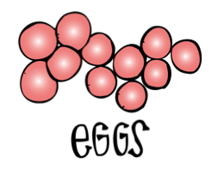 | 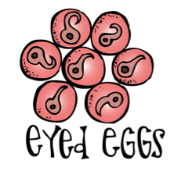
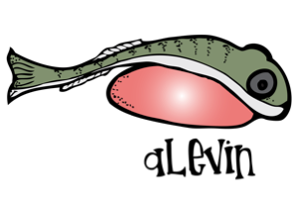 | 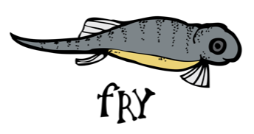
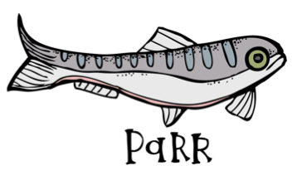 | 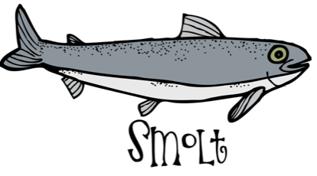
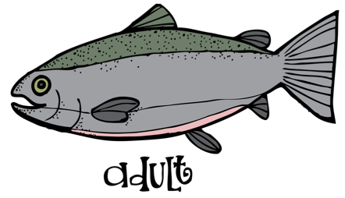

Appendix B - Toilet Paper Roll Fish Instructions
- Flatten the cardboard tube. Paint the tube in full. Optional: show a photo of an Atlantic Salmon if they’d like to paint it as one.
- Cut a rounded end for the fish’s head and two slits at an approximate 45º angle for the tail - younger children may need assistance with this step (if meeting virtually a parent can assist).
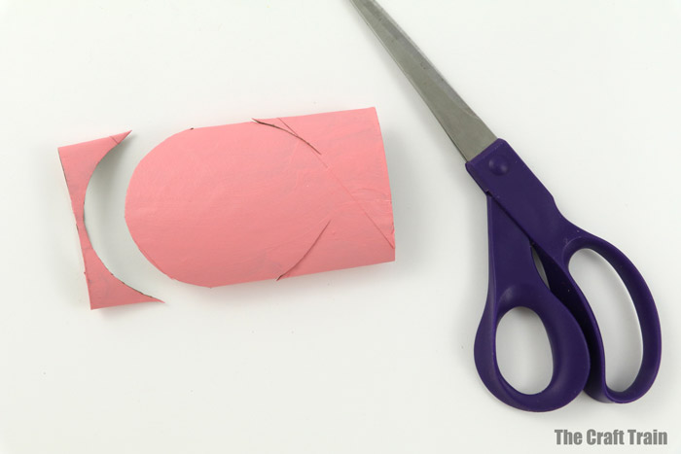

- Fold the angled cut inwards both forwards and backwards and then tuck it inside the fish to create the tail (see video or photos if this sounds confusing) - younger children may need assistance with this step (if meeting virtually, a parent can assist).
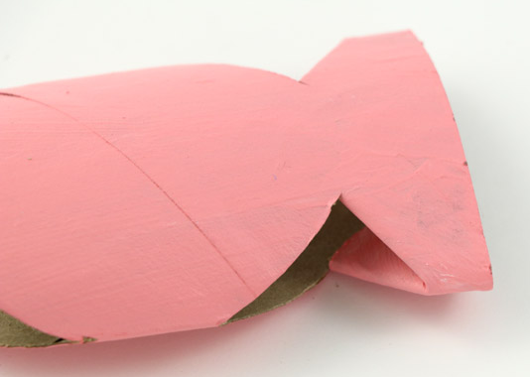
- Decorate your fish with paints/stickers/glitter/etc. Glue a googly eye onto each side (or draw with a marker) and draw on a mouth with a marker or other craft supplies.
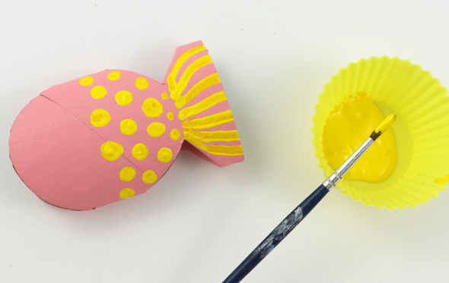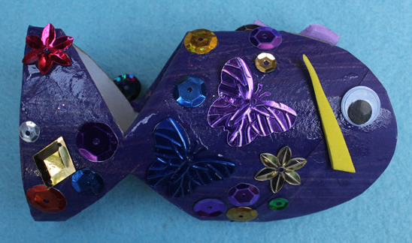

Appendix C: Salmon Survival Scenarios

◆ If you are green, you were just born from an egg and are a happy little alevin ready to grow and explore. Move 2 spaces/start with 2 tokens.
◆ If you are yellow, you were just born from an egg and are a happy little alevin - sadly you became a snack for a bigger fish. Move 1 space/start with 1 token.
◆ If you are red, you did not survive past the egg stage. Do not move/start with no tokens.
◆ If you are green, your egg sac provided you with lots to eat and you grew into a nice and strong fry. Move 1 space/take 1 token.
◆ If you are yellow, your egg sac provided you with enough food to grow into a surviving fry. Move 1 space/take 1 token.
◆ If you are red, your egg sac provided you with just enough food to grow into a surviving fry, but you were eaten by a bigger fish. Do not move/start with no tokens.
◆ If you are green, you have grown nice and big over the last 2-3 years and are ready to migrate to the ocean. Move 1 space/take 1 token.
◆ If you are yellow, You’ve grown big, but not quite big enough, you have to wait another year before migrating. Move 1 space/take 1 token.
◆ If you are red, you were caught too young by a fisherman - you were too small so they threw you back in. Move 1 space/start with 1 token.
◆ If you are green, you’ve successfully spent years at sea and are ready to spawn, it's time to start your migration to freshwater. Move 1 space/take 1 token.
◆ If you are yellow, you need a little more time to grow and develop. Move 1 space/take 1 token.
◆ If you are red, you were eaten by a bigger fish. Do not move/do not take any tokens.
◆ If you are green, you’ve successfully made it to freshwater where you will spend this year’s winter months. Move 2 spaces/take 2 tokens.
◆ If you are yellow, you’re finally big enough, time to migrate to freshwater. Move 1 space/take 1 token.
◆ If you are red, you were caught in a net as bycatch. Do not move/do not take any tokens.
◆ If you are green, you’ve survived several months in freshwater and are ready to move upstream. Move 1 space/take 1 token.
◆ If you are yellow, you’ve survived several months in freshwater and are ready to move upstream. Move 1 space/take 1 token.
◆ If you are red, you were able to move to freshwater to prepare for next year’s spawning season. Move one space/take one token.
◆ If you are green, you have found a mate and are ready to spawn. Move 2 spaces/take 2 tokens.
◆ If you are yellow, you have found a mate and are ready to spawn. Move 1 space/take 1 token.
◆ If you are red, you are caught by off season poachers and do not survive long enough to spawn. Do not move/do not take any tokens.
◆ If you are green, you are able to spawn and lay thousands of healthy eggs in your nest. Move 2 spaces/take 2 tokens.
◆ If you are yellow, you were able to lay thousands of eggs, but some were eaten by other species. Move 1 space/take 1 token.
◆ If you are red, there was pollution run-off in your freshwaters and you grew sick and you died. Do not move/do not take any tokens.
◆ If you are green, it’s exhausting laying eggs - take the time to rest in the freshwater once more as a kelt before returning to sea. Move 1 space/take 1 token.
◆ If you are yellow, you’ve laid your eggs and now it's time to rest - you are more prone to predators as a kelt and get eaten. Do not move/do not take any tokens.
◆ If you are red, someone has set up an illegal net in the area you are swimming and you get caught. Do not move/do not take any tokens.
◆ If you are green, you make your way back out to the ocean to spend several years regaining your strength to make the journey once more. Move 2 spaces/take 2 tokens.
◆ If you are yellow, you may not have made it to spawn again, but your eggs begin successfully hatching to restart the life cycle. Move 1 space/take 1 token.
◆ If you are red, you never did make it to spawn - many factors interfered with your life cycle. Do not move/do not take any tokens.

Green should have taken 15 steps/tokens
Yellow should have taken 9 steps/tokens
Red should have taken 2 steps/tokens

